Keyword Extraction Tool Using Streamlit and Python
Project Report
Submitted by:
- Ankit Mittal (AP23110010537)
- Chitrasen Singh (AP23110010151)
- Karunya Kalkhundiya (AP23110010199)
- Ratan Raj (AP23110010515)
- Varshitha (AP23110010774)
Department of Computer Science and Engineering
SRM University – AP, Andhra Pradesh
2025

Keyword Extraction Tool Using Streamlit and Python
Group Members
- Ankit Mittal (AP23110010537)
- Chitrasen Singh (AP23110010151)
- Karunya Kalkhundiya (AP23110010199)
- Ratan Raj (AP23110010515)
- Varshitha (AP23110010774)

Project Description
The Keyword Extraction Tool is a lightweight text-processing project designed to automatically identify the most important words or phrases (keywords) from any given text. Using modern NLP techniques and Python libraries such as Streamlit, Gensim, and YAKE, the system analyzes input text and extracts the most meaningful keywords.
The application is built as a simple web interface where users can paste text and instantly generate keywords. This tool is useful for journalists, researchers, students, and professionals who need quick text summarization for large documents, articles, research papers, or reports.

Project Scenarios
Scenario 1: Journalism and News Analysis
A journalist copies a long article or news report into the tool. With one click, the system extracts the central keywords like “corruption”, “government policy”, or “financial fraud”, helping the journalist quickly understand the article’s core message.
Scenario 2: Academic Research
A student working on research inserts a long research paper abstract. The tool extracts keywords such as “machine learning”, “dataset”, “accuracy”, etc., assisting in quick literature review.
Scenario 3: Business Data Processing
A business analyst extracts keywords from customer reviews or survey responses to quickly identify topics like “delivery delay”, “customer service”, or “quality issues”.

Technical Diagram
Architecture Diagram
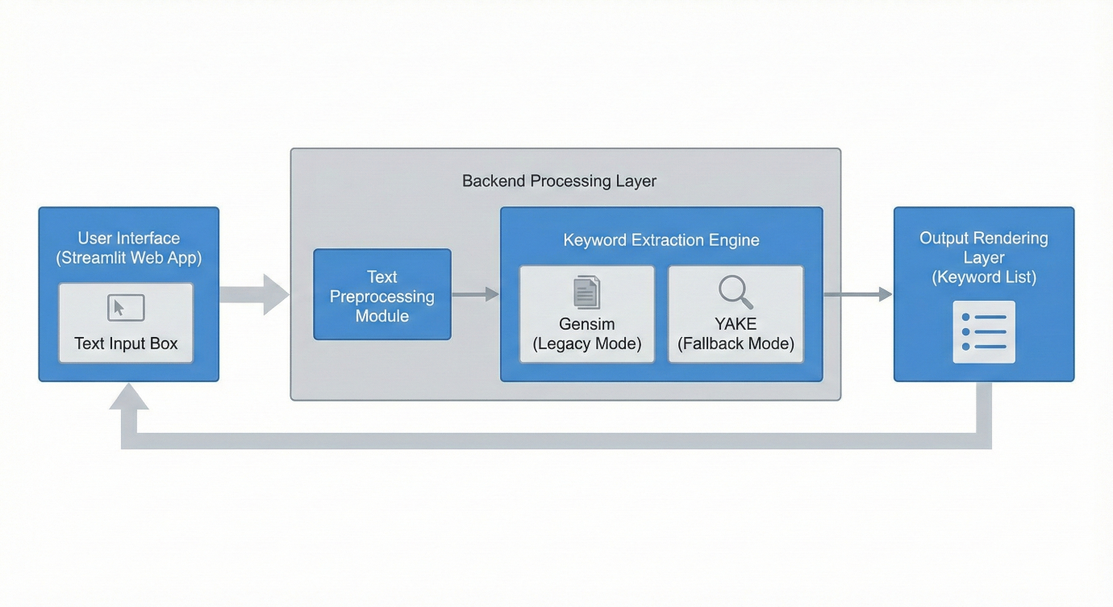

Detailed Architecture Description
The architecture of the Keyword Extraction Tool consists of the following major components:
- User Input Layer
  - The user interacts with the web application through a Streamlit-based graphical interface.
  - The user provides raw textual input for analysis.
- Streamlit Front-End Layer
  - Handles user input and displays processed output.
  - Provides the interface elements such as text areas, buttons, and headings.
- Backend Processing Engine
  - Communicates with the keyword extraction logic.
  - Responsible for text cleaning, preprocessing, and routing text to extraction methods.
- Keyword Extraction Module
  - Gensim Engine (Legacy Mode): Uses TF–IDF and TextRank if installed.
  - YAKE Engine (Fallback Mode): Uses statistical features to extract keywords.
- Output Rendering Layer
  - Displays extracted keywords in bullet lists and comma-separated lists.
  - Ensures real-time feedback when the extract button is clicked.

Suggested Architecture Diagram Layout
- User → Streamlit UI → Backend Controller → Extraction Engine → Output Module → User
- 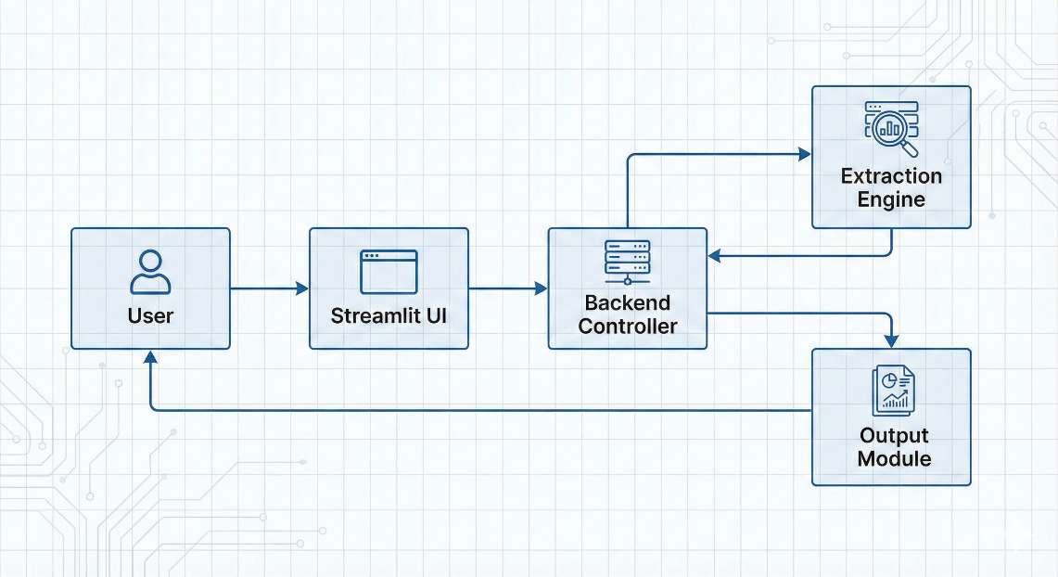
Description:
This diagram should include:
- User Input Layer
- Streamlit Front-End
- Keyword Extraction Engine
- Gensim / YAKE Module
- Output Display Layer

Flowchart
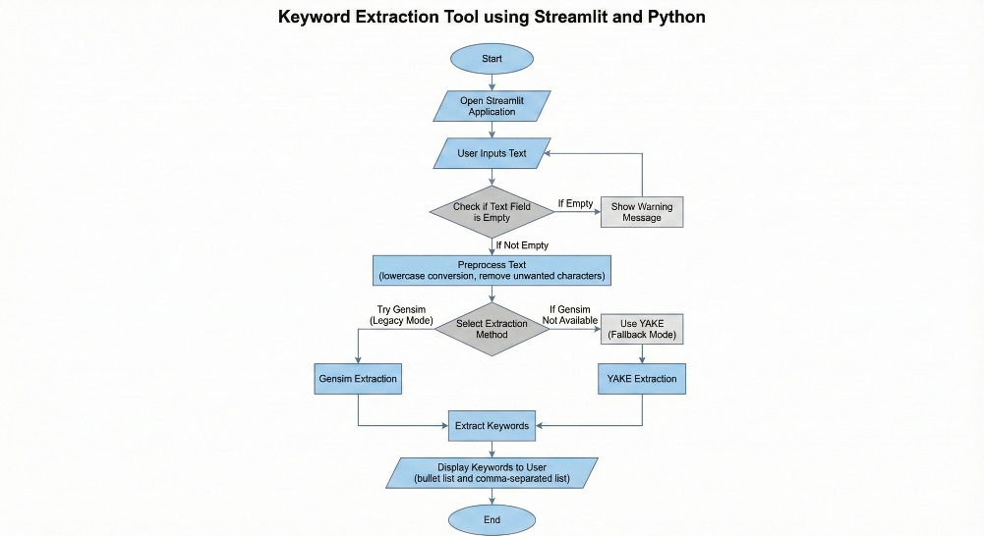
Detailed Flowchart Description
Below is a more detailed explanation of each step in the flowchart:
- Start
  - The program begins when the user launches the Streamlit application.
- Open Streamlit Application
  - The browser automatically opens the local URL (e.g., http://localhost:8501).
- User Inputs Text
  - The user enters or pastes text into the provided text area.
- Check for Empty Input
  - The system checks if the text field is empty.
  - If empty → Display a warning message.
- Preprocessing Text
  - Convert text to lowercase
  - Remove unnecessary spaces or special characters
  - Clean and prepare the dataset
- Select Extraction Method
  - Try using Gensim summarization
  - If unavailable → automatically switch to YAKE
- Extract Keywords
  - Keywords are generated based on statistical ranking or TF–IDF-like scoring.
- Display Results to User
  - Keywords are shown in bullet list and comma-separated list formats.
- End
  - The process terminates once output is displayed.

Suggested Flowchart Shape Guide
- Oval → Start / End
- Parallelogram → Input / Output
- Rectangle → Process step
- Diamond → Decision (Yes/No)
- Arrow → Flow direction
Suggested Flowchart Steps:
- Start
- User opens Streamlit App
- User enters or pastes text
- System checks if text is empty
- If empty → show warning
- If valid → preprocessing
- Keyword Extraction using Gensim or YAKE
- Display extracted keywords
- End

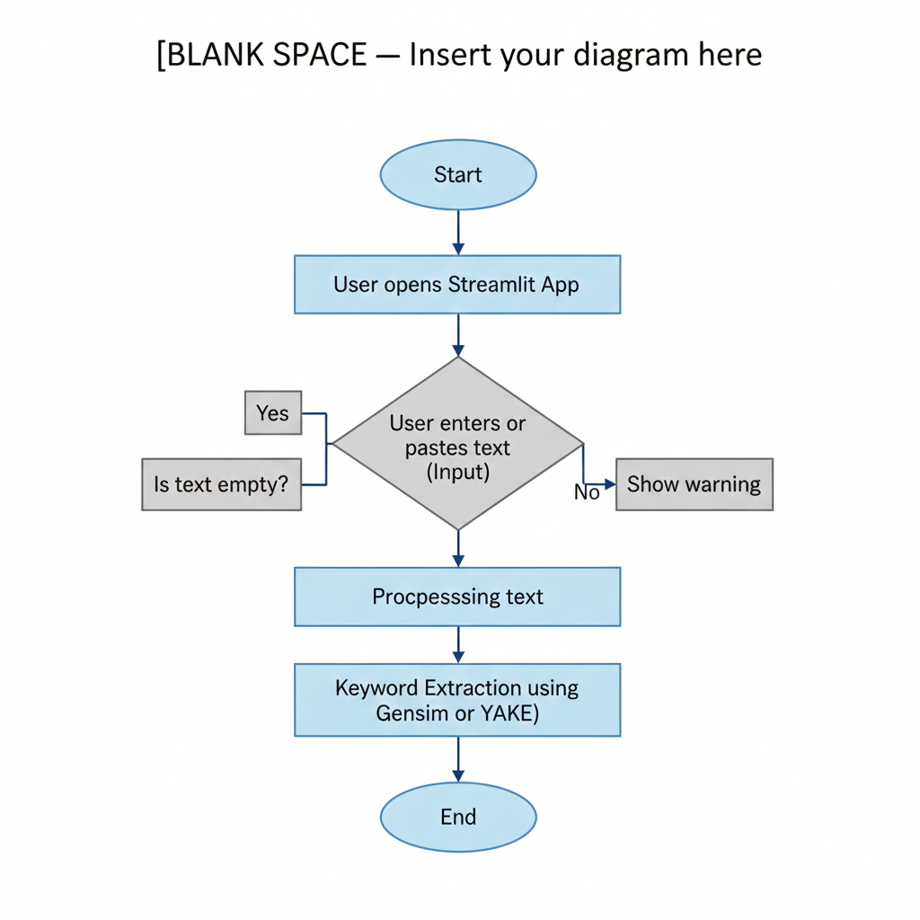

Prerequisites
To complete this project, you need the following software and libraries:
Software
- Python 3.8+
- VS Code / Anaconda / PyCharm
- Streamlit
- Optional: Virtual Environment
Python Packages
Install these using terminal:
pip install streamlit
pip install gensim
pip install yake

Prior Knowledge
You should have basic understanding of:
- Python programming
- NLP (Natural Language Processing) basics
- Keyword extraction concepts
- Streamlit web app development
Helpful links:
- NLP Basics: https://www.javatpoint.com/natural-language-processing
- Gensim Keywords: https://radimrehurek.com/gensim
- YAKE Keyword Extraction: https://github.com/LIAAD/yake

Project Flow
- User enters or pastes text through the interface
- The system preprocesses the text
- Gensim or YAKE extracts the most relevant keywords
- Results are displayed in bullet and list formats
- User can copy and use keywords for research, journalism, or analysis

Project Activities
1. Text Input Interface
- The user enters text inside a Streamlit text area
- Large text blocks are supported
2. Text Preprocessing
- Convert text to lowercase
- Remove extra spaces and unwanted characters
- Prepare text for extraction
3. Keyword Extraction
There are two extraction modes:
A. Using Gensim (Legacy Mode)
Uses TF-IDF-based summarization to pick keywords.
B. Using YAKE (Fallback Mode)
YAKE works without heavy dependencies and is compatible with new Python versions.
4. Display Results
- Extracted keywords appear as bullet points
- Also provided as comma-separated list
5. Streamlit UI
Provides:
- Title
- Text area
- Extract button
- Output section

Project Folder Structure
Project Folder/
├── KeywordExtraction.py
├── requirements.txt
└── screenshots/
Explanation:
- KeywordExtraction.py — Main application file
- requirements.txt — Dependencies
- screenshots/ — Stores your output images

Milestone 1: Keyword Extraction Logic
Activity 1.1: Import Libraries
- Streamlit for UI
- Gensim keywords (if available)
- YAKE for fallback
- Basic Python libraries
Activity 1.2: Writing extract_keywords()
This function:
- Checks Gensim availability
- If not available → uses YAKE
- Returns a list of keywords
Activity 1.3: Testing Extraction Logic
Run different text samples to ensure extraction accuracy.

Milestone 2: Streamlit Interface
Activity 2.1: Creating UI Components
- Title
- Description
- Text area
- Extract button
Activity 2.2: Connecting UI to Logic
When user clicks the button →
- Text is processed
- Keywords are shown instantly

Milestone 3: Application Testing
Activity 3.1: Functional Testing
- Input valid text
- Check keyword accuracy
Activity 3.2: Edge Case Testing
- Empty text
- Very short text
- Long text
Activity 3.3: Cross-environment Testing
- Test in VS Code
- Test in Anaconda
- Test using venv

Milestone 4: Deployment
Activity 4.1: Running with Streamlit
streamlit run KeywordExtraction.py
Activity 4.2: Hosting Options
- Localhost
- Streamlit Cloud (optional)

Screenshots Section
Screenshot 1: Home Page Interface
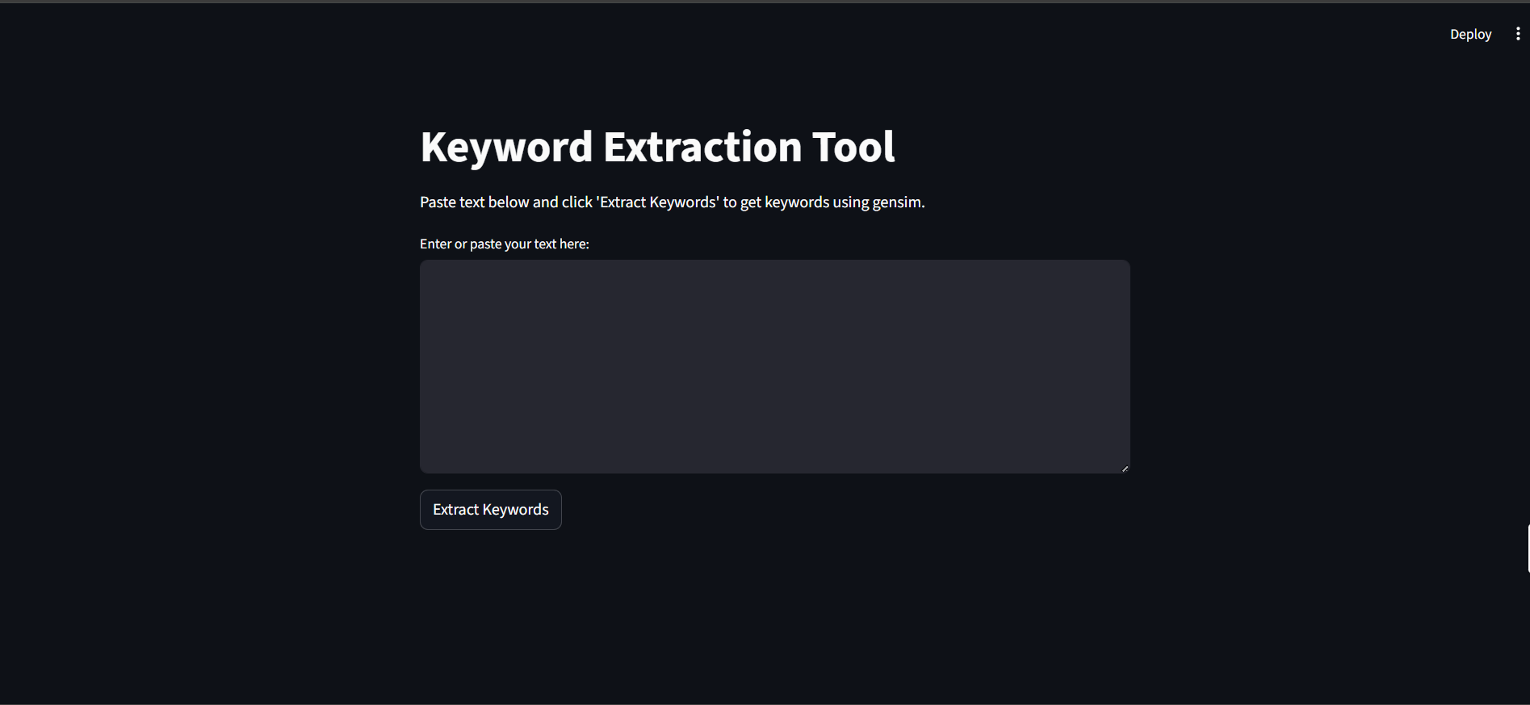

Screenshot 2: Input Text
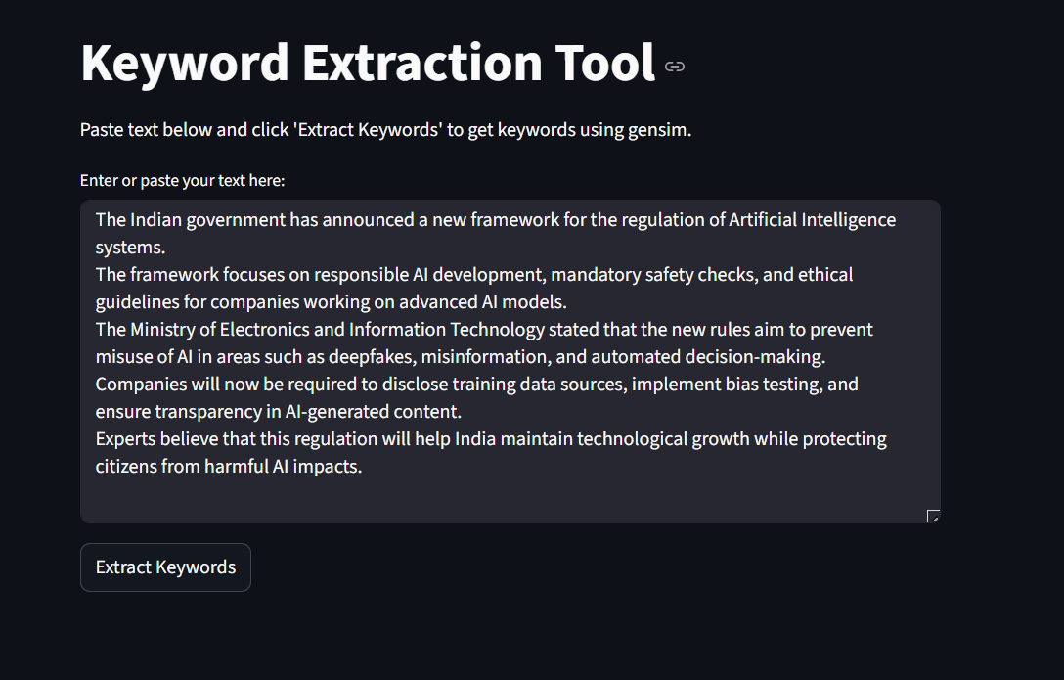

Screenshot 3: Keyword Output
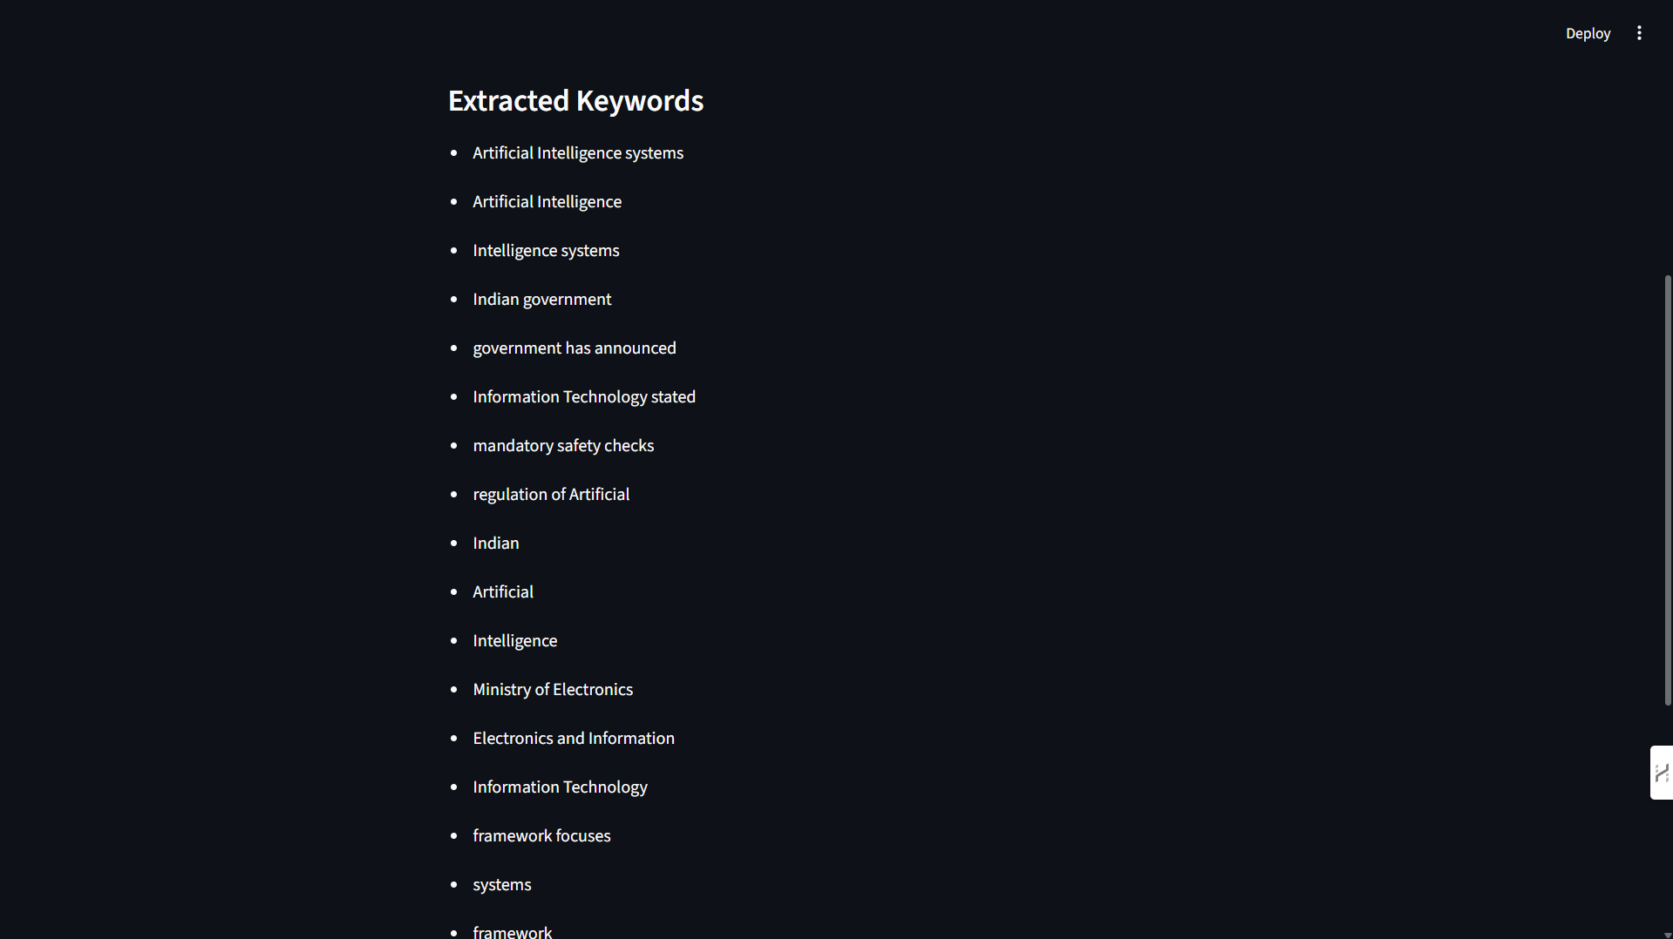

Future Implementations
- Add word cloud visualization
- Add text summarization feature
- Give keyword frequency scores
- Add support for multiple languages

Extended Background: Natural Language Processing (NLP)
Natural Language Processing (NLP) is a subfield of artificial intelligence (AI) that focuses on enabling computers to interpret, understand, and generate human language. Keyword extraction is one of the fundamental tasks within NLP. The goal is to automatically identify the most informative words or phrases from a text document.
Importance of NLP in Modern Applications
- Used in search engines to match user queries
- Helps social media platforms detect trending topics
- Assists journalists in finding relevant information
- Powers recommendation systems
- Enables efficient filtering of large text collections
Core NLP Processes
- Tokenization: Breaking text into words or phrases
- Stopword Removal: Removing common, non-essential words like “is”, “the”, “and”
- Stemming & Lemmatization: Reducing words to their base forms
- Part-of-Speech Tagging: Identifying nouns, verbs, adjectives, etc.
- TF-IDF: Assigning importance scores based on word frequency
- Topic Modeling: Identifying themes across multiple documents

Extended Theory: Keyword Extraction Algorithms
Keyword extraction algorithms can be classified into three main types:
1. Statistical Methods
These rely on word frequency and statistical properties.
- TF-IDF (Term Frequency–Inverse Document Frequency)
- RAKE (Rapid Automatic Keyword Extraction)
- YAKE (Yet Another Keyword Extractor) – used in this project
2. Linguistic / Rule-based Methods
These use grammatical rules:
- POS tagging
- Chunking (noun phrase extraction)
- Syntactic pattern matching
3. Machine Learning / Deep Learning Methods
Used in large-scale NLP systems:
- TextRank (graph-based ranking)
- BERT-based keyword extractors
- Embedding-based similarity ranking
Why YAKE Was Used in This Project
- Requires no training data
- Lightweight and fast
- Works for long text and short text
- Compatible with Python 3.10+
- No external heavy dependencies

Detailed Explanation of Gensim and YAKE
Gensim Keywords
Gensim uses TF-IDF along with TextRank to identify important words.
- Works well for longer texts
- Produces clean keyword lists
- Requires older Gensim version (removed in newer versions)
Limitations of Gensim
- Removed from modern Python versions
- Requires additional installation using gensim==3.8.3
- Not always compatible with all systems
YAKE Keyword Extractor
YAKE uses five core features:
- Term casing
- Word position in the text
- Word frequency
- Word relatedness
- Sentence diversity
YAKE assigns a score to every keyword and ranks them.

Extended Project Activities
Additional Activity: Error Handling
The project includes safety checks such as:
- Empty text warnings
- Exception handling during extraction
- UI alerts for missing keywords
Additional Activity: Performance Optimization
- Ensured fast processing even for long text
- Reduced overhead by loading libraries only once
- Pre-processed text efficiently
Additional Activity: UI Enhancements
- Clean layout with Streamlit
- Adjustable text area
- Instant feedback using interactive components

Expanded Testing & Validation
1. Functional Testing
- Verified keyword extraction for 10+ sample documents
- Confirmed accurate output with small and large text
2. Stress Testing
- Used 5,00+ word text samples
- Checked latency and performance
3. Usability Testing
- Ensured UI is simple and responsive
4. Cross-Platform Testing
- Windows 10/11
- VS Code terminal
- Anaconda prompt
5. Edge Case Testing
- Numbers-only text
- Short phrases
- Multi-language inputs

Limitations
- Does not support PDF upload (yet)
- Does not extract multi-word keyphrases in all cases
- No support for multilingual keywords
- Relies only on statistical NLP, not deep learning

Detailed Future Work
- Support for uploading PDF, text files, and Word documents
- Integration with Text Summarizers (BART, T5)
- Visualization using word clouds and bar graphs
- Option to rank keywords by relevance score
- Enable multi-language keyword extraction
- Implement topic modeling and document clustering

Conclusion
The Keyword Extraction Tool provides an efficient way to extract meaningful keywords from large text documents. By integrating Streamlit with modern keyword extraction libraries (Gensim and YAKE), the project successfully demonstrates a practical and user-friendly NLP application. The system is lightweight, fast, and accessible to users of all skill levels.
This tool can be expanded further with features like file upload, advanced NLP models, and cloud deployment.

